How to: Calculate image statistics for individual polygons (shape file)
- Load raster image, and display it
- Open vector map:
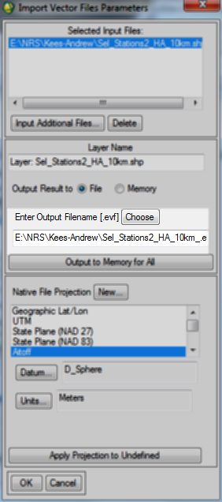
- Usually I accept the output name of the ENVI vector output; click OK
- In the vector list, select the new layer. Then click ‘File | Export layers to ROI’
- In the next dialog select the image file opened in step 1
- The ‘Export EVF Layers to ROI’ dialog opens, use the settings as below, and click OK:
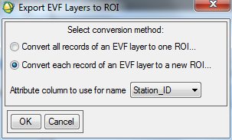
- In the image display click ‘Tools | Region of Interest… | ROI Tool’
- Click ‘ Select All’, then click ‘Stats’. This takes some time…. (several minutes)
- You end up with:
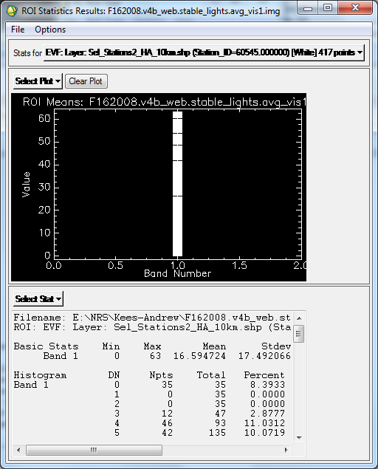
- Click ‘File | Save all ROI results to text file…’. Choose a file name and click OK.
- The output text file contains more information than needed and is not organized in a table format, so:
- Now run the script:
nrs_extract_stat,<stat file> ,<field_name>,<output csv file>
where:
stat file = the file you just created
field_name = the name of the attribute selected in step 6
output csv file = name of the output file
- The output file is tab delimited and can be loaded in Excel.

